List of opensource tools to boost data analysis with Python Pandas library
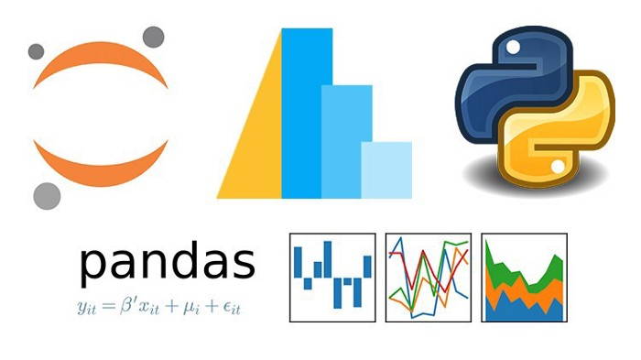
Pandas is a Python library for data analysis. Wes McKinney started it in 2008 out of a need for a effective and flexible quantitative analysis tool, pandas has grown into one of the most popular Python libraries.

pandas documentation - pandas 1.5.3 documentation

The reference guide contains a detailed description of the pandas API. The reference describes how the methods work and…
pandas.pydata.org

In my search, I found the following open-source python libraries that will immensely boost your Pandas workflow the moment you start using them.
pandas-profiling: Generate EDA report of data in one-line of code.
- Link: https://bit.ly/pd-profiling
D-Tale: Visualizer for pandas dataframe.
- Link: https://bit.ly/py-dtale
PandasML: Pandas, sklearn and matplotlib integrated.
- Link: https://bit.ly/pandasml
Jupyter-Datatables: Enrich the default preview of a DataFrame in jupyter notebook.
- Link: https://bit.ly/jupy-dtables
Pandera: Provides a flexible and expressive API for performing data validation on dataframe-like objects to make data processing pipelines more readable and robust.
- Link: https://pandera.readthedocs.io/en/stable/#
SummaryTools: Boost the describe() method in Pandas.
- Link: https://bit.ly/summarytools
Sidetable: Charge the value_counts() method in Pandas.
- Link: https://bit.ly/py-sidetable
Sketch: Generate code/insights about data by asking questions in natural language.
- Link: https://bit.ly/py-sketch
Deepchecks: Generate a comprehensive validation report of your data.
- Link: https://bit.ly/deepchks
Pandas Flavor: Extend Pandas to attach methods to the dataframe object.
- Link: https://bit.ly/pd-flavor
Pandarallel: Parallelize Pandas across multiple CPU cores.
- Link: https://bit.ly/pandarallel
Geopandas: Work with Geospatial data in Pandas.
- Link: https://bit.ly/geo-pd
DuckDB: Run SQL queries on dataframes.
- Link: https://bit.ly/duckdb
Modin: Boost Pandas’ performance up to 70x by modifying the import.
- Link: https://bit.ly/modin-guide
PivotTableJS: Create pivot tables by using drag and drop functionality.
- Link: https://bit.ly/pivottablejs
Missingno: Visualize missing values in your dataset.
- Link: https://bit.ly/py-missingno
Pandas Alive: Create animated charts for pandas dataframes.
- Link: https://bit.ly/pd-alive
Skimpy: Supercharge the describe() method in Pandas.
- Link: https://bit.ly/py-skimpy
Pandas-log: Debug pandas pipeline using step-by-step logging.
- Link: https://bit.ly/py-log
tsflex: Process time series and perform feature extraction.
- Link: https://bit.ly/tsflex
Mars: A tensor-based framework for scaling numpy, pandas, scikit-learn, and Python functions.
- Link: https://bit.ly/py-mars
nptyping: Apply type hints for Pandas data frames.
- Link: https://bit.ly/nptyping
popmon: Profile your data to determine its stability.
- Link: https://bit.ly/py-popmon
Gspread-pandas: Interact with Google sheets through pandas dataframes.
- Link: https://bit.ly/pd-gsheets
pdpipe: Create pandas pipeline easily and intuitively.
- Link: https://bit.ly/py-pdpipe
PrettyPandas: Prettify the dataframe when printed.
- Link: https://bit.ly/PrettyPandas
Dora: An intuitive API for data cleaning, processing, feature selection, visualization, etc.
- Link: https://bit.ly/py-dora
Pandapy: The speed of NumPy combined with Pandas’ elegance.
- Link: https://bit.ly/pandapy
PyJanitor: A clean API for cleaning data.
- Link: https://bit.ly/pyjanitor
swifter: Speed-up the apply() method in Pandas.
- Link: https://bit.ly/py-swifter
Mito: Analyze data in Jupyter by editing a spreadsheet.
- Link: https://bit.ly/mito-ds
Visual Python: GUI-based Python code generator for data science
- Link: https://bit.ly/visual-py
tqdm: Add progress bars to Pandas methods.
- Link: https://bit.ly/tqdm-pd
Lux: Automatic data visualization.
- Link: https://bit.ly/pd-lux
AutoClean: Automated data preprocessing & cleaning.
- Link: https://bit.ly/py-autoclean
pytablewriter: Write a dataframe in various formats: AsciiDoc / CSV / HTML / JSON / LaTeX / Markdown / Excel / TOML / TSV / YAML, etc.
- Link: https://bit.ly/pytablewriter
itables: Pandas dataframes as interactive datatables.
- Link: https://bit.ly/itables
PandasGUI: A GUI for Pandas dataframes.
- Link: https://bit.ly/PandasGUI
tabula-py: Extract table from PDF into Pandas dataframe.
- Link: https://bit.ly/tabulapy
Pingouin: Perform statistical testing on Pandas dataframe.
- Link: https://bit.ly/pypingouin
Dexplot: Create many types of beautiful data visualizations with a simple, consistent, and intuitive API.
- Link: https://bit.ly/dexplot
A huge shout out to the creators of these libraries. These libraries really increases pandas usability. There might be many more libraries to make the tabular datasets easy to analyze in Python.
Happy data exploring everyone!

